**\* *Notice of Pest Control* * *Treatment***

* **Date(s) of planned treatment:**  ­­­­­­­­­­­­­­­­____________________
* **Re-entry (if applicable):** _______________________________________________
* **Extenuating circumstances may require unplanned treatments. To confirm treatment dates or for special instructions please call:**

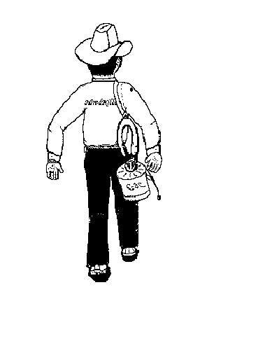

**1-512-847-2495**

* **National Pesticide Information Center 1-800-858-7378.**
* **A consumer information sheet may be obtained from the management.**

**Pest Control applicators are licensed and regulated by: Texas Department of Agriculture, Structural Pest Control Service,**

**P.O. Box 12847, Austin, Texas 78711-2847, Phone 866-918-4481, fax 888-232-2567.**